USA flag

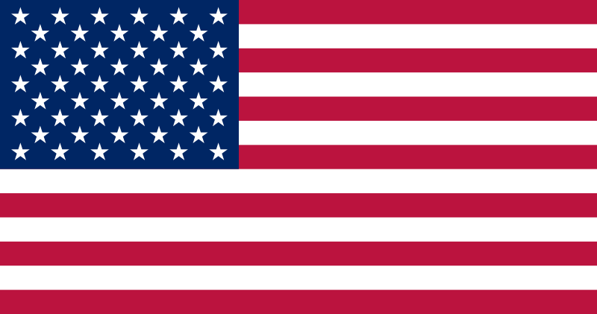

What does the American flag “say” to its’ citizens and to other people?

What do you think it is
saying to us?

The fifty stars on the flag represent the 50 states and
the 13 stripes represent the original thirteen that rebelled against the British Monarchy and became the first states
in the Union.

What does Mexico
want the world to know about its country and culture?

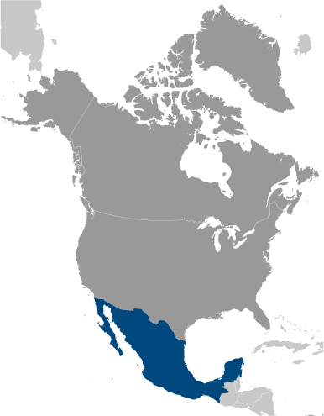

France flag

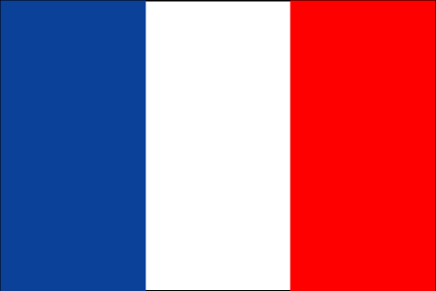
The basic design of the flag of Mexico is taken from the French
Tricolor flag. France conquered part of Mexico for a while.

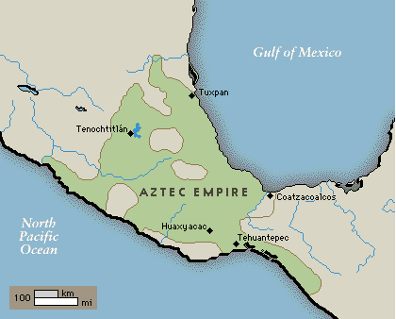
Spanish flag

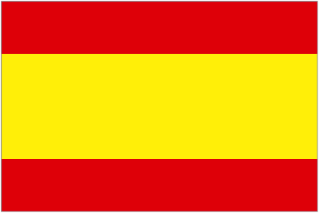

In 1519, Cortez sailed from Spain to conquer Mexico City.

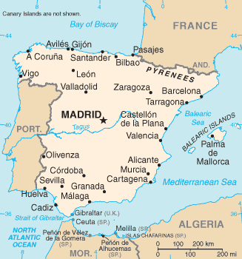

Mexico’s flag

History and Meaning of the Mexican Flag

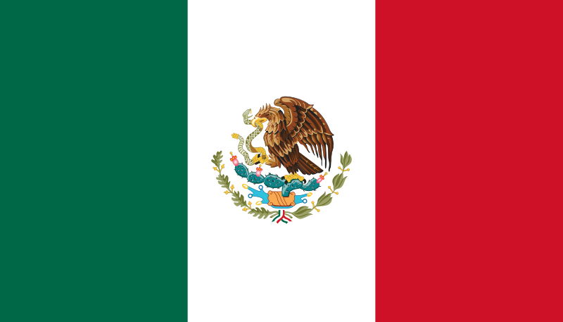

- hope (green)
- unity (white)
- blood of the national heroes(red)

The Mexican flag consists of three vertical bands in green, white
and red, with the Mexican coat of arms (which portrays an eagle on
a prickly pear cactus with a snake in its beak and talons)
in the center of the white band. The red, white and green are the colors of the national liberation army of Mexico.

Aztec legend told them to build their new city on the exact spot where they saw an eagle sitting on a cactus, eating a snake.
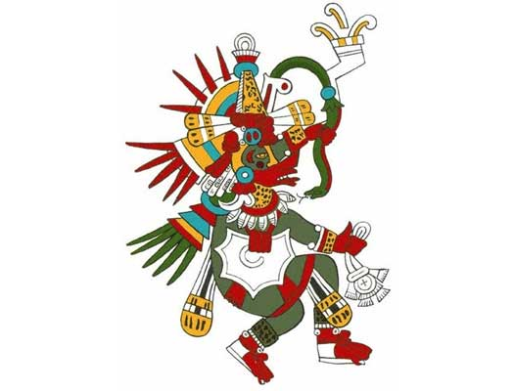

Prickly Pear Cactus

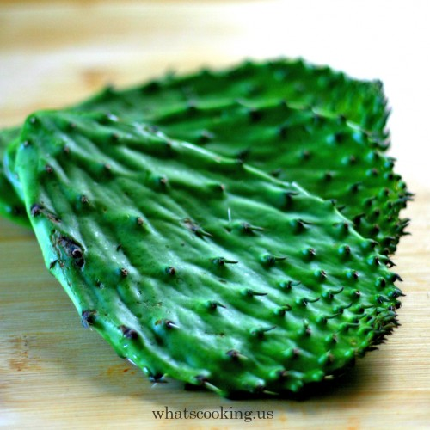
Mexico’s Coat of Arms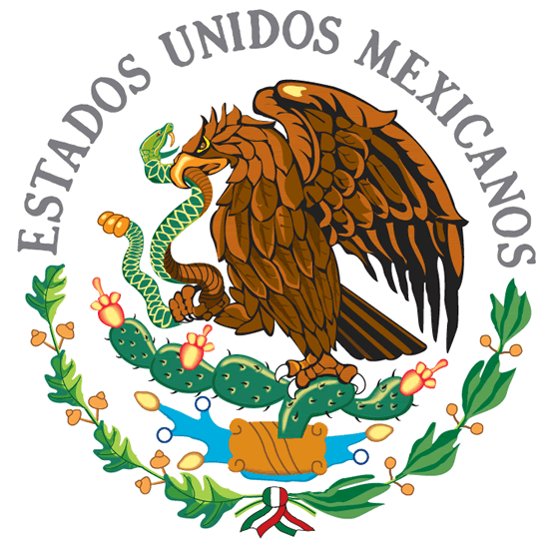
Mexican Golden Eagle
perched on a prickly pear cactus eating a snake

The Mexican Coat of Arms is taken from an Aztec legend
, which recounts the way in which the Aztecs came to choose
the site where they built their capital city of Tenochtitlan (where Mexico City stands today).

The Aztecs
also known as the Mexica ("meh-shee-ka"),
were a nomadic people traveling from the north of the country. Their leader was informed in a dream by the god of war, Huitzilopochtli, that they were to settle in the place where they would find an eagle on a prickly pear cactus holding a serpent. The place where they saw this sight was quite inhospitable - a swampy area in the center of three lakes, but this is where they settled and built the great city of Tenochtitlan.
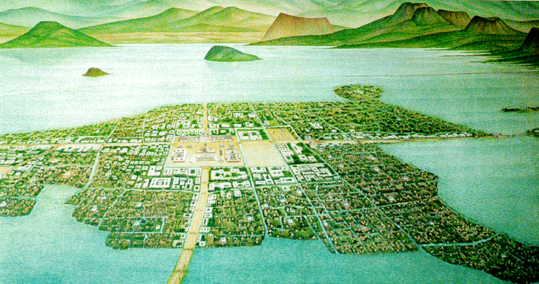

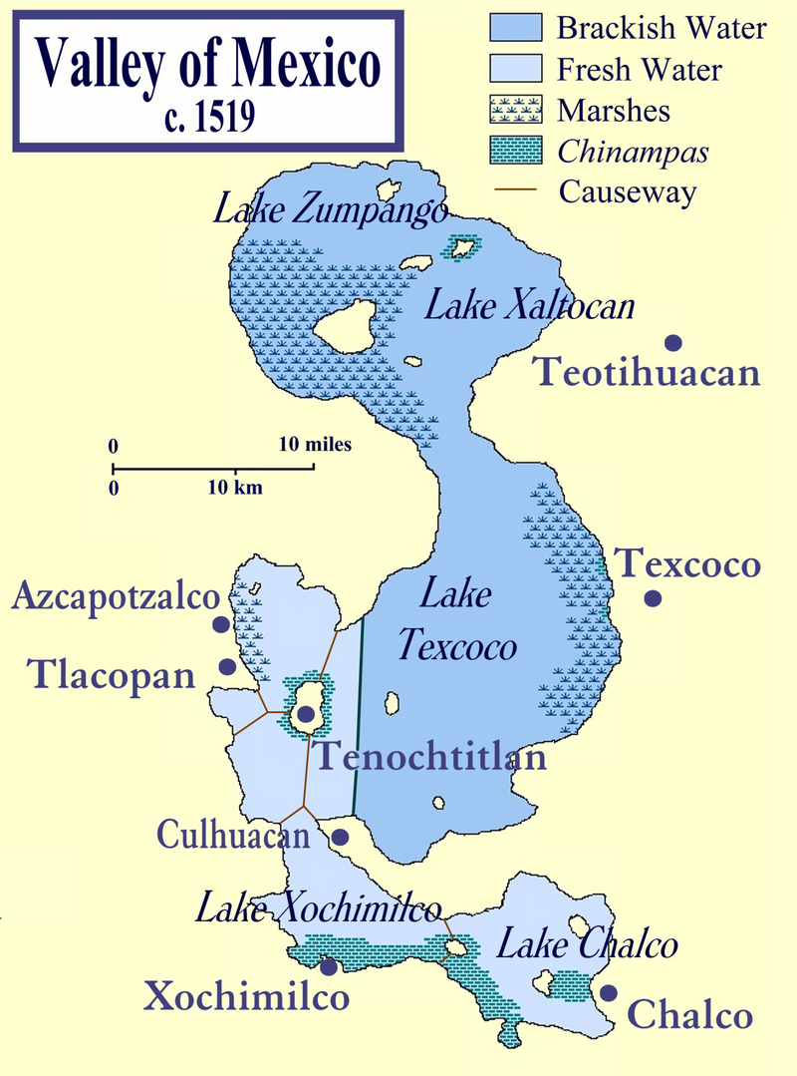

World’s 6th largest city

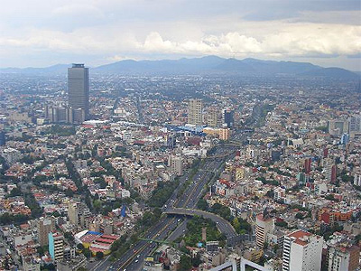
Mexico City (population 23 million)
Seattle (population 3.4 million) 2010 census data

Flag Protocol
When the Mexican flag is displayed, Mexicans stand at attention with their right arm placed in a salute over their chests with the palm facing downward.

National Anthem

http://www.nationalanthems.info/mx.htm

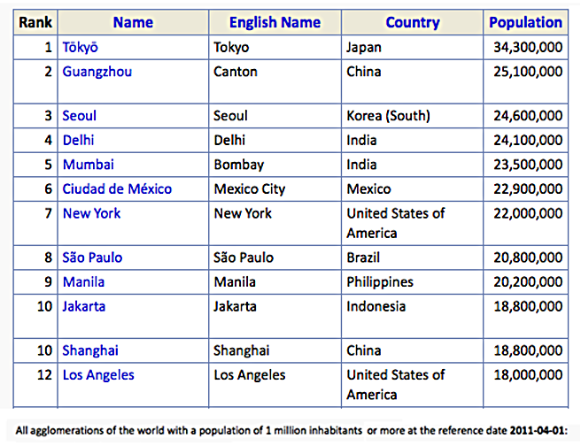

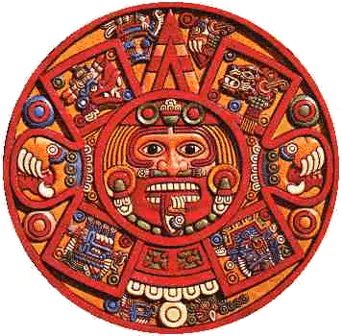

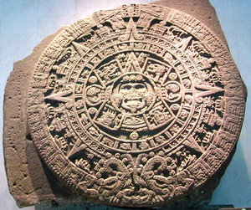

Mexico
Agriculture - products:
corn, wheat, soybeans, rice, beans, cotton, coffee, fruit, tomatoes; beef, poultry, dairy products; wood products
Industries:
food and beverages, tobacco, chemicals, iron and steel, petroleum, mining, textiles, clothing, motor vehicles, consumer durables, tourism

Exports - commodities:
manufactured goods, oil and oil products, silver, fruits, vegetables, coffee, cotton

Imports - commodities:
metalworking machines, steel mill products, agricultural machinery, electrical equipment, car parts for assembly, repair parts for motor vehicles, aircraft, and aircraft parts

