Who is Sir Isaac Newton?

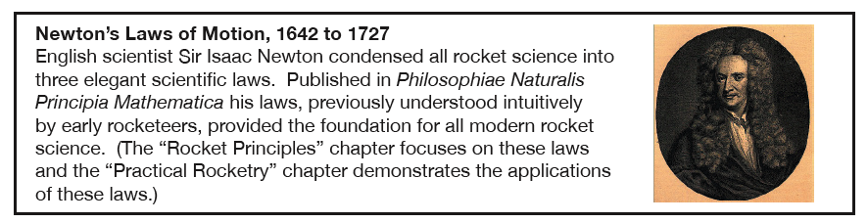

- Newton's 1st Law: An object in motion stays in motion unless acted upon by an outside force.
- Newton's 2nd Law: Force=mass x acceleration.
- Newton's 3rd Law: For every action, there is an equal and opposite reaction.

University of Washington Bothell, Box 358550, 18225 Campus Way NE, Bothell, WA 98011-8246 (425) 352-5340

Title: Screws / by Sally M. Walker and Roseann Feldmann ; photographs by Andy King.
Author: Walker, Sally M. Pub Info: Minneapolis : Lerner Publications, c2002.
Bothell/CCC Childrens Lit TJ1338 .W35 2002
Title: Inclined planes and wedges / by Sally M. Walker and Roseann Feldmann ; photographs by Andy King.
Bothell/CCC Childrens Lit TJ147 .W35 2002
Title: Wheels and axles / by Sally M. Walker and Roseann Feldmann ; photographs by Andy King.
Bothell/CCC Childrens Lit TJ181.5 .W36 2002

Curriculum Kit
Bothell Curriculum Kits TJ170 .S56 1993 disc
Bothell Curriculum Kits TJ170 .S56 1993 manual AVAILABLE , LIB USE ONLY
Summary Lessons on simple machines using an interactive CD-ROM computer file and manipulatives. Takes a trip around the
world to explore the modern and ancient applications of six simple machines: inclined plane (in Egypt); wedge (in France);
lever (in Lebanon); screw (in Italy); pulley (in Sicily); and the wheel (in China)

Looking at Simple Machines
Author: Helen Frost
Title: What are screws? Red Brick Learning, (series)
Pub Info: CapstonePress.com

Books:
Ardley, Neil. The Science Book of Motion. Chicago, IL: Harcourt Brace Jovanovich, Publishers, 1992.
Easy-to-read and understand book of experiments on motion.
Balls and Ramps: An Elementary INSIGHTS Hands-On Inquiry Science Curriculum. Newton, MA: Education
Development Center, Inc., 1994.
Inquiry-based, hands-on science curriculum to teach science in the true spirit of scientific exploration and discovery.
Gartrell, Jack E., Jr. Methods of Motion: An Introduction to Mechanics Book One. Washington, DC: National Science Teachers Association, 1992.
Teacher curriculum resource.
Lafferty, Peter. Force and Motion. New York, NY: Dorling Kindersley, Inc., 1992.
Eyewitness Science Book. Explores the principles of force and motion, describing how they have been applied from ancient to modern times.
Marson, Ron. Motion. Canby, OR: TOPS Learning Systems (Task card series), 1990.
Teacher curriculum resource.
Marson, Ron. Pendulums. Canby, OR: TOPS Learning Systems (Science with simple things series),
1983.
Teacher curriculum resource.
Sauvain, Philip Arthur. Motion. New York, NY: Macmillan, 1992.
Defines motion, describes its different types, and discusses how motion is used in bicycles, escalators, typewriters, and other types of machines.

