MEXICO

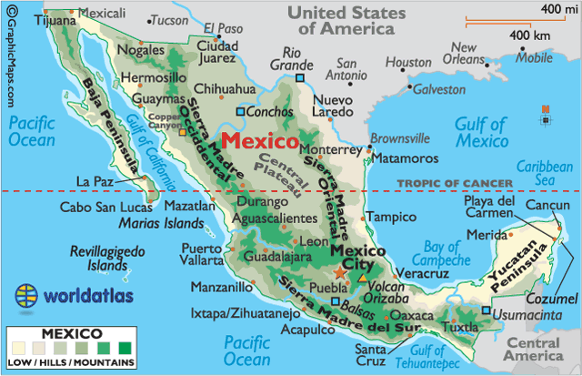
http://www.worldatlas.com/webimage/countrys/namerica/mx.htm

- Currency: Mexican Peso (MXN) (conversion rates)
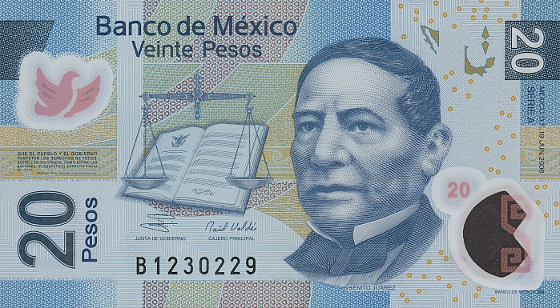
Name Orgin:
- Mexico's name is derived from its capital city, originally named by the Aztecs, and closely related
to the Mexica tribe.
- Capital City: Mexico City (pop. 21.2 million)
Mexico Flag:

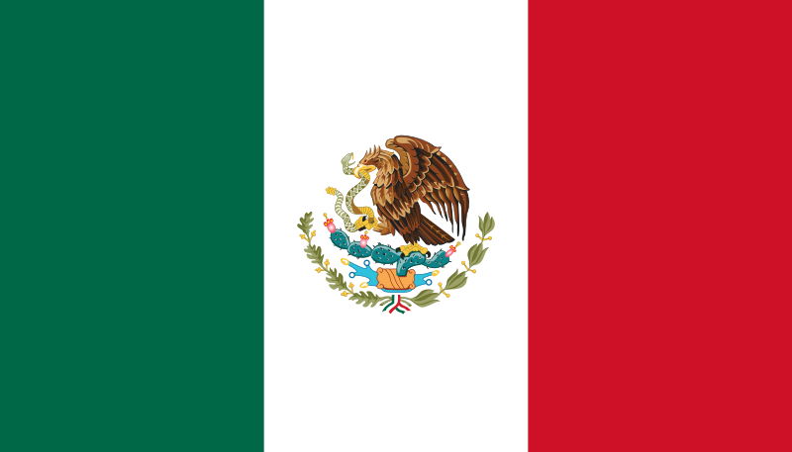

The basic design of the flag of Mexico is taken from the French Tricolor flag. The red, white and green are the colors of the national liberation army of Mexico. The coat of arms (centered) in the white band is the badge of Mexico City, the country's capital. Its main feature is an eagle, and it is said that an Aztec legend told them to build their new city on the exact spot where they saw an eagle sitting on a cactus, eating a snake.

Mexico Coat of Arms:

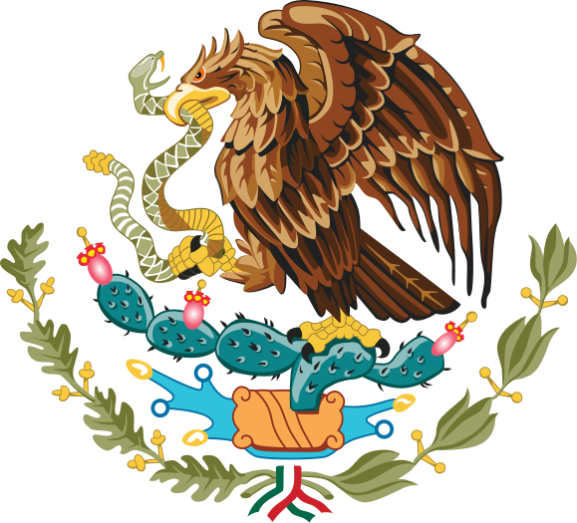
The coat of arms, also used in the Seal of the United Mexican States, depicts a Mexican Golden Eagle perched on a prickly pear cactus eating a snake. This symbolism had strong religious connotations to the Tenochtitlan people. To the Europeans, it symbolized the triumph of good over evil.

National Anthem

http://www.nationalanthems.info/mx.htm
Mountains:
The Sierra Madre Occidental range runs north to south, from the Sonora-Arizona border southeast through Sonora, Chihuahua, Sinaloa, Durango, Zacatecas, Nayarit, Jalisco, Augascalientes to Guanajuato, where it joins the Sierra Madre del Sur and the Transverse Volcanic Axis of central Mexico.
These steep mountains are cut through with canyons, including Copper Canyon, the deepest in North America. The highest point is Cerro Mohinora at 10,662 ft (3,250 m)
Sierra Madre del Sur is a mountain range in southern Mexico, extending 1,000 m from southern Michoacan east through Guerrero to eastern Oaxaca.

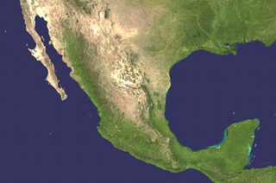
Copper Canyon

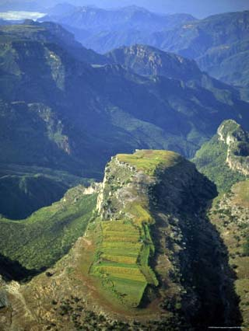
Coastal Plains:
The Gulf Coastal Plain lies to the east of the Sierra Madre Occidental range fronting the Gulf of Mexico.
The very narrow Coastal Plain along the Pacific Ocean coastline rises quickly into the foothills of the mountains, while the Gulf of Mexico and Caribbean coastlines are wider and rise gently into the interior.
Plateaus:
The Central Mexican Plateau consumes much of northern and central Mexico. It extends from the border with the USA on the north to the Cordillera Neovolcanica in the south, with the Sierra Madre Occidental mountain range on the west and the Sierra Madre Oriental on the east. It averages 5,988 ft (1,825 m) above sea level and is covered mostly by deserts and xeric shrublands.
Volcanos:
A long line of ancient volcanoes (many still active) extends from the Pacific Ocean (north of Guadalajara) on eastward to the Gulf of Mexico, just to the south of Veracruz. Pico de Orizaba Volcano, the third highest mountain in North America, is located here.
Peninsulas:
The mountainous Baja Peninsula extends about 750 miles (1,200 km) south from the U.S. border. Mexico's limestone Yucatan Peninsula is tree-covered, with thick tropical jungles along its borders with Central America countries.
The Yucatan Peninsula separates the Caribbean Sea from the Gulf of Mexico. It is east of the Isthmus of Tehuantepec, which is a geographic partition separating Central America from the rest of North America.

http://www.worldatlas.com/webimage/countrys/namerica/printpage/mxna.htm

Rivers:
Mexico has nearly 150 rivers; most are small, unnavigable, and 70% drain into the Pacific Ocean. Some of the large rivers include the Balsas, Conchos, Grijalva, Panuco, Papaloapan and Usumacinta. (Not all are shown on the map for space reasons)
The Rio Grande, rising in the San Juan Mountains of the U.S. State of Colorado, flows generally south to the Gulf of Mexico for 1,885 miles (3,000 km) and forms much of Mexico's northern border with the United States. The two largest lakes in the country of Mexico are Lake Chapala and Lake Cuitzeo.

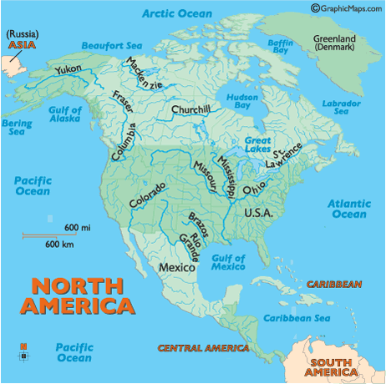

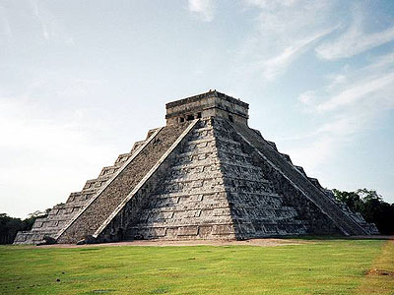

Chichen-Itza

