Group Roles/Expectations
Group Roles
Facilitator: Gets the team off to a quick start
Makes sure everyone understands the task
Organizes the team so they can complete the task
“Who knows how to start?”
“Does everyone get what to do?
“I don’t get it yet...can someone help?”
“We need to keep moving so we can...”
Resource Manager: Collects supplies for the team
Calls the teacher over for team questions
Cares for and returns supplies
Organizes clean up
“I think we need more information here. I’ll call the teacher over.”
“We need to clean up. Can you...while...?”
Recorder/Reporter: Gives update statements on team’s progress
Makes sure each member of team records the data
Organizes and introduces the report
“We need to keep moving so we can...”
“I’ll introduce the report, then...”
“Did everyone get that in your notes?”
Team Captain: Encourages participation
Encourages group to use the norms
Finds compromises
Substitutes for absent roles
“Remember, no talking outside our team.”
“Let’s find a way to work this out.”
“We need to listen to each member of the team.”

Norms:  - You have the right to ask for help. You have the responsibility to help others without doing the work for them.  - All questions are group questions.  - Pay attention to what others need  - Stay together in your team | Materials:  Isometric dot paper,  Pencils, Colored Pencils, Markers,  Tape,  Pyramid Worksheet, Symbols Guide,  Materials for large Pyramid (assorted material choices on back table)  - Thin cardboard  - Construction Paper  - Tag-board
Pyramid Task Sheet
Secrets of the Pyramids:
The Pharaoh's Architect was recently crushed under a 5,000 block of marble. Many slaves were lost in the tragic accident. How can you design and construct a pyramid that will prove worthy enough for your group to be chosen as the Pharaoh's new architect?
Task: Construct a pyramid and write a hieroglyphic message to the Pharaoh.
1) Each group constructs one shape of their choice from the following types of pyramids:
a. A pyramid whose base is an equilateral triangle
b. A pyramid whose base is an isosceles triangle
c. A square-based pyramid constructed so that the four triangular faces are NOT all congruent to each other.
d. A pyramid with a rectangular base.
e. A pyramid with a rhombus base.
2) Initial/Practice Pyramid: The first pyramid your group builds is not the final product.
- Using the isometric dot paper, create one 2-dimensional pyramid net (from the list above) to use as a model for the final pyramid.
- Build the practice pyramid, to make sure the net folds into a pyramid correctly.
- Calculate the surface area of the entire pyramid and record it on the worksheet.
- Create a formula that would work for calculating the surface area of your pyramid and record it on the worksheet.
- The Reporter gets approval from the teacher before moving on to the next step.
3) Group Decisions:
Group decides upon how big the final pyramid will be and the materials. Remember that the pyramid needs to be large enough to display the hieroglyphic message to the Pharaoh. Record your decisions on the worksheet.
4) Final Pyramid:
- Using what you already know about scale, create a larger version of the practice model pyramid.
- Calculate the surface area of the entire pyramid and record it on the worksheet.
- Create a formula that would work for calculating the surface area of your pyramid and record it on the worksheet.
5) Secret Message
- To prepare for your secret message and for the class discussion, discuss and record answers to the remaining questions on the worksheet.
- As a group decide upon the most important math concept of this activity and record it on your worksheet.
- Use the hieroglyphic translator paper to translate your message.
- Draw and color the message on your pyramid. (Hint: do this in the 2D net form.)
- Record this message on your worksheet.
- Put Pyramid into its FINAL form to prepare for the Gallery Walk.
- Reporter gets approval from teacher before moving on to next step.
6) Gallery Walk Like an Egyptian
- Each group displays their pyramid and their worksheet showing comparisons and formulas.
- Each group walks around with Translator Paper and a notebook to translate and record each group’s message.
- The groups put a post-it note on each group’s work with one question they had about the pyramid or worksheet.
7) Class Discussion: Secrets of the Pyramids
- Make sure each group member understands how you arrived at your conclusions as all may be asked to participate during class discussion.
Pyramid Worksheet

Group Name: __________________________________________________ Date: ______________
Practice Pyramid’s
Surface Area in centimeters:
Formula?

Final Pyramid
Size of base? (Make sure it is big enough to record your hieroglyphic message.)
Type of material?
Pyramid’s Surface Area in centimeters:
Formula?
Compare/Contrast 2D to 3D
What is the same between your 2D net and your 3D pyramid?
What is different?
What other patterns did you observe?
Geometric Attribute Chart

3D Shape | Shape of base | # of Faces | Shapes of Faces | Area of ea. Face | # of Vertices | # of Edges | Total Surface Area (cm²)
Square Pyramid | Square | 5 | Square  And Triangle |  | 5 | 8

Symbols
Create your message using hieroglyphic and Geometric symbols.
What is the most important learning/key concept that your group learned today?
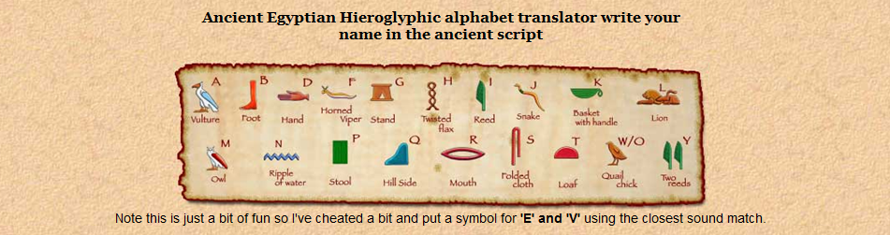
Geometry Symbols
Symbol | Symbol Name | Meaning / definition | Example
∠ | angle | formed by two rays | ∠ABC = 30º
∟ | right angle | = 90º | α = 90º
AB | line | line from point A to point B
* | ray | line that start from point A
| | perpendicular | perpendicular lines (90º angle) | AC | BC
|| | parallel | parallel lines | AB || CD
≅ | congruent to | equivalence of geometric shapes and size | ∆ABC ≅ ∆XYZ
~ | similarity | same shapes, not same size | ∆ABC ~ ∆XYZ
Δ | triangle | triangle shape | ΔABC ≅ ΔBCD
| x-y | | distance | distance between points x and y | | x-y | = 5

