Scientific Journal
Simple Machines
Motion / How Things Move
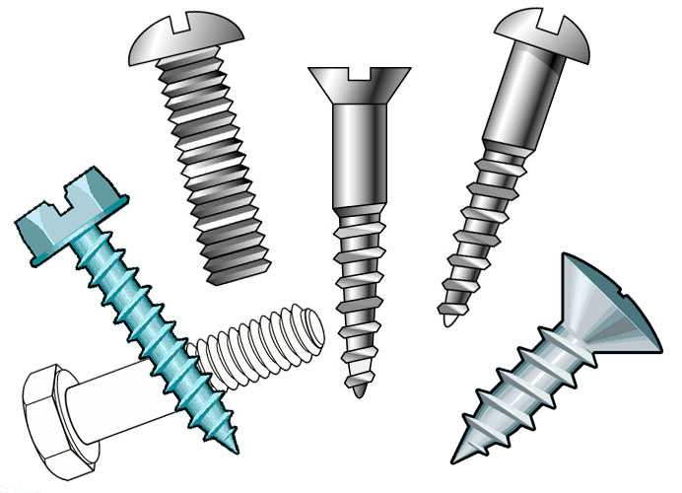
This experiment conducted by scientist:

Date :

Materials:

Draw a picture of the experiment: (clearly label with new vocabulary)

Vocabulary:

screw, threads, inclined plane, cylinder, motion, force, push, pull
Hypothesis: What do you think will happen?

What I think will happen in this experiment is . . .

Procedure: Explain the Steps. What did you do?

Step 1:

Step 2:

Step 3:

Results / Observations: What really happened.

What surprised me is . . .

A screw is an inclined plane wrapped around a cylinder.

What is another name for the 3-D shape of a pencil?

What did you wrap around the screw?

What is the longest edge of the paper triangle called?

What are the small diagonal marks on the screw?

In what direction does the screw move when it is turned?

Did you notice anything push or pull? What happened?

Something new that I learned is . . .

One question I have is . . .

Another Drawing:

Your Simple Machine Invention:

