David Repyak — Technology Safety Plan

SAFETY
Teaching students online safety and responsible online expression is critical to forming appropriate behavior and healthy habits of mind. With new-found technological freedom students can learn to use these tools wisely. Speaking with students about technology and education, President Obama issued a warning about Facebook.
“I want everybody here to be careful about what you post on Facebook, because in the YouTube age whatever you do, it will be pulled up again later somewhere in your life. That’s number one,” - President Barak Obama

DIGITAL Citizenship
According to the ideas proposed in the LWSD Power Standards, “Students understand human, cultural, and societal issues related to technology and practice legal and ethical behavior.” At the 2nd and 3rd grade level this includes;
- respect for equipment
- respecting privacy of other’s data and workspace
- differentiating between original work and plagiarized work
- identifying internet danger signs and seeking help
Technology Operations and Concepts
According to the ideas proposed in the LWSD Power Standards, students will “demonstrate a sound understanding of technology concepts, systems and operations.”
At the 2nd and 3rd grade level this includes:
- identifying input/output devices
- use of peripheral devices
(printer, mouse, right click, docu camera, keyboard, ActiveBoard, ActiveVote)
- open, save, print and publish a completed work
- use basic text formatting, graphics, and editing tools
(spacing, bullets, color justification, hyperlinks, cut/paste, and spell check)
- create and present multimedia using a template (PowerPoint)
- know home row position of keyboard, working toward typing 15 wpm
- access network software and server
Respect for self & others.
Today’s virtual world is a social training ground for appropriate respectful behavior.
Parents and educators can support learning by teaching students to respect others' virtual property, privacy, and identity as much as in the real world. Digital citizenship begins with supervision and modeling safe practice as students learn to navigate virtual social spaces.

Email Protocol - Rules
Email is a privilege and not a right. To have email you need to follow some rules.
- Use your email for important and school related communication.
- Any email you send can be shared with others and traced to you.
- If you don’t want everyone to know something, don’t send it in an email.
- Be polite and never send bullying, harassing, or hurtful email.
- Always write a subject in your email message.
- Once you send an email, you can’t get it back;
avoid sending emails when you are upset.
- Typing in all CAPITALS is considered SHOUTING.
- Share your email address only with people you know and never put
your email address on public websites.
GMail Privacy Settings
Watch a video tutorial on how to set up sub-accounts for kids under a teacher's Gmail account so that the teacher first views any email coming to the student.
- Step 1 – assign a sub email address in your inbox for each student
- Step 2 – apply a label and create a filter for each student
- Step 3 – monitor student email as it is routed through the teacher’s inbox
Digizen
Learn to make responsible decisions on line, avoid cyber bullying, and use safe password practices in this Digital Citizen game.
http://www.digizen.org/resources/cyberbullying/interactive/

Childnet International:
Tips to safely explore the virtual world we live in begin with respect for self and others. Cyber bullying , sexting, blogging, cell phone safety, smart video gaming are among the topics covered on this website for parents, youth, teens, and educators.

Cell Phone Safety Tips:
Cell phones are increasingly full-blown handheld computers, and everything that can be done on the Web via computer – photo-sharing, Web browsing, game playing, tune-swapping, real-time text chat, and talking – can be done on a phone.
Tips for safe and constructive cell phone use:
- Smart socializing
- Phones are personal
- Bullying by phone
- Sexting
- The value of "presence"
- Down time is good
- Social mapping
Technology in the Classroom
The power of technology as a teaching tool is not to be underestimated. Classrooms have ceiling mounted projectors that can be used to show paper documents, educational video, and streaming student broadcasts from the office or around the world. My classroom will incorporate a powerful tool called ActiveBoard. Teachers continually find innovative ways to engage students in the learning process with this resource. Lesson plans are delivered with the aid of interactive media an animation. Seamless assessment is conducted on the fly with an ActiveVote tool, as teachers modify and clarify learning. Students have access to computers in the classroom, the library and in the computer lab. With the help of grant funding NetBooks (mini laptops) can be successfully included in the daily routine.

Strong Educational Value and Purpose
Inside and outside the classroom: web pages will be used to communicate assignments, curriculum content, share resources, home work, upcoming events, and class projects. Inquiry and project based learning are perfect pedagogical methods to apply in blogs, wikis, pod-casts, video tutorials, Glogster (virtual posters), VoiceThread (collaborative audio, image, video, presentations), Google Map mashups, and an array of Web 2.0 tools to give life to team collaboration.

Ensuring equitable access –
In this Edutopia article, the author argues that low income kids especially need access in school to Web 2.0 tools. Concrete steps for getting sites unblocked are discussed.
Students and Social Networking:
Students today are unleashing the power of sharing ideas and influencing opinion.
A digital cloud gives rise to self-expression and offers a forum for students to present their identity and opinions. Yet, how much of student's time online is spent using effective pedagogy? Social Networking should harness educational value through a focus on collaborative projects. This chart demonstrates that students are talking about education online.

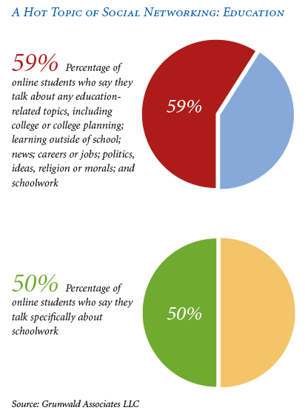
NSBASafety.pdf http://www.NSBA.org

Student Networking Activity:
The way students use networking in their lives today: Posting messages, sharing music, sharing videos, sharing photos, blogging, creating content, participating in collaborative projects, submitting articles, taking quizzes, creating reviews and surveys.
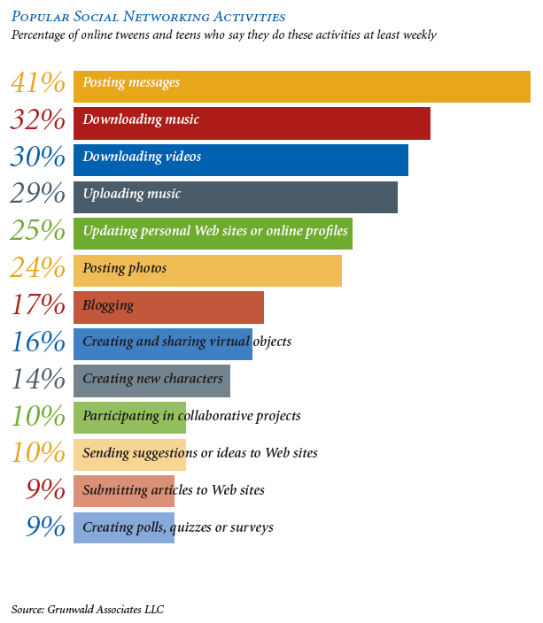

NSBASafety.pdf http://www.NSBA.org

Interactive Educational Resources –
Software and server-based educational web sites offer enrichment across all content areas. The level of research available today including museums, universities, public libraries, state organizations, primary documents, government services, and non-profit business is astounding. Students have access to a growing list of software products:

For additional technology ideas please visiting my website and blog.

- Accelerated Math – A program that creates appropriate level math problems.
- Rosetta Stone - A program used to teach English vocabulary to ELL students.
- Headsprout – A literacy program for primary students, with lively animation, focuses on letters and sounds.
- Fast Forward – An intensive intervention program helping students make the connections between letters and sounds.
- Learning Planet – primary alphabet learning tools http://www.learningplanet.com/act/abcorder.asp?contentid=172
- Illuminations - http://illuminations.nctm.org/
Mathematic virtual manipulatives
- Reading Planet - http://www.rif.org/kids/readingplanet/activitylab.htm
- Sentence Starship – BBC home page builds vowel sounds http://www.bbc.co.uk/schools/starship/english/games/word_jumbler/small_sound/standard.shtml
- Construct a word – beginning, middle and ending letter sounds http://www.readwritethink.org/files/resources/interactives/construct/index.html
- BrainPop – educational animated video http://www.brainpopjr.com
- Sadlier Oxford – grade level appropriate phonics tools
http://www.sadlier-oxford.com/phonics/student.cfm#gradek
- Journal Writing Topics - http://thewritesource.com/writing_topics/#wot
- Microsoft Office – A full productivity office suite.
- Internet Research - Grade level appropriate research with teacher supervision.
- Email – Used with teacher supervision to share information.

